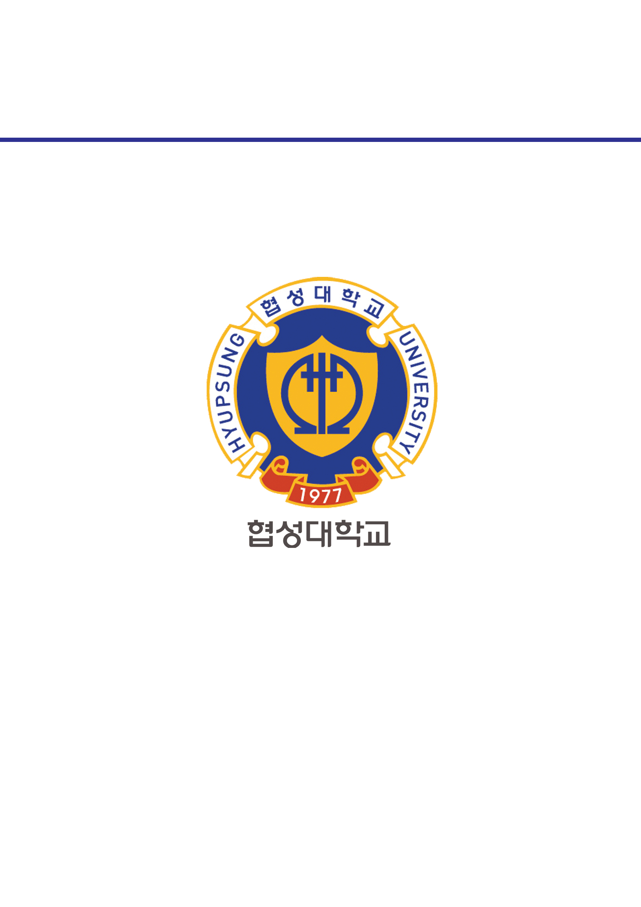­­

과목명 : IOT시스템응용

담당교수 : 봉진숙

학번 : 20170660

학과 : 컴퓨터공학과

이름 : 김동현

**REPORT**

**1. ThreadExam.Synchronized**

코드) Calculator.java

**package** threadExam.Synchronized;

**public** **class** Calculator {

**private** **int** memory;

**public** **int** getMemory() {

**return** memory;

}

**public** **synchronized** **void** setMemory(**int** memory) {

**this**.memory = memory;

**try** {

Thread.*sleep*(2000);

} **catch** (InterruptedException e) {

// **TODO** Auto-generated catch block

e.printStackTrace();

}

System.***out***.println(Thread.*currentThread*().getName() + ": " + **this**.memory);

}

}

코드) User1.java

**package** threadExam.Synchronized;

**public** **class** User1 **extends** Thread {

**private** Calculator calculator;

**public** **void** setCalculator(Calculator calculator) {

**this**.setName("User1");

**this**.calculator = calculator;

}

@Override

**public** **void** run() {

calculator.setMemory(100);

}

}

코드) User2.java

**package** threadExam.Synchronized;

**public** **class** User2 **extends** Thread {

**private** Calculator calculator;

**public** **void** setCalculator(Calculator calculator) {

**this**.setName("User2");

**this**.calculator = calculator;

}

@Override

**public** **void** run() {

calculator.setMemory(50);

}

}

코드) MainThreadExample.java

**package** threadExam.Synchronized;

**public** **class** MainThreadExample {

**public** **static** **void** main(String[] args) {

Calculator calculator = **new** Calculator();

User1 user1 = **new** User1();

user1.setCalculator(calculator);

user1.start();

User2 user2 = **new** User2();

user2.setCalculator(calculator);

user2.start();

}

}

실행 결과)

